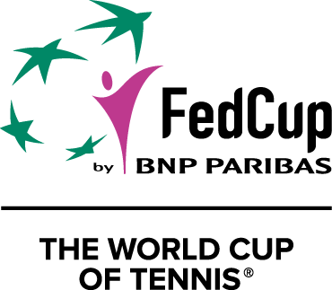
2019 Fed Cup by BNP Paribas semifinal

France v Romania
Kindarena, Rouen, France
Saturday 20 – Sunday 21 April 2019

MEDIA ACCREDITATION APPLICATION FORM

Deadline for Media Accreditation – Monday 1st April 2019

Please read the application form and corresponding instructions thoroughly. Failure to provide the correct information will delay your application.

- Please complete the following application form and return to the relevant contact person.

- The ITF, French Tennis Federation (FFT) and Romanian Tennis Federation (FRT) reserve the right to approve or deny accreditation applications. Completion of this application form does not guarantee accreditation.

- You will receive written confirmation via email on the status of your request after the closing date.

- For TV enquiries, please contact Carly O’Hara (ITF TV Department) at Carly.OHara@ITFTennis.com.

- All applications from freelance media must be accompanied by a letter from the media organisation you are representing at the Fed Cup Final. This should be sent to the relevant contact below. Please note that fan and other non-news websites will not be considered for accreditation.

- Each media representative must supply one original colour passport-sized photograph, sent by email to the contact person shown below. This photo should be saved in form Surname-Name.jpg.

- Media accreditation passes are not transferable and must be collected by the accredited representative.

- Please note that there will be free WiFi in the media work area. Please indicate on this form whether you will require a private ISDN line. We will come back to you if you need to order one.

- There are two official media hotels: Ibis Rouen Centre Rive Droite and Ibis Rouen Champs de Mars. The deadline for bookings is April 5th. See booking details on page 2.

- Please note that any media bringing TV/video recording equipment on site must declare their equipment in advance in order to be able to film on site. Recording equipment declaration form is attached and must be sent back completed to the relevant contact below.

PLEASE DIRECT APPLICATION FORMS AND ENQUIRIES TO:
FRENCH and INTERNATIONAL MEDIA
Contact: Dorothée LECONTE
French Tennis Federation (FFT)
Tel: +33 (0)631395167
Email: dleconte@fft.fr

ROMANIAN MEDIA
Contact: Adrian MACARIE
Romanian Tennis Federation (FRT)
Tel: +40749513479
Email: amacarie@frt.ro

__________________________________________________________________
1. PERSONAL DETAILS

Organisation _______________________________________________________________________________

Address ___________________________________________________________________________________

Country _____________________________________ Postal Code ___________________________________

Email ______________________________________________________________________________________

Telephone __________________________________________________________________________________

Name of applicant ________________________ (family name)_____________________________ (first name)

Birthdate _______________________ Birth place (city and country) ________________________

Contact email address (if different from above) ___________________________________________________

Category
Writer Radio Photographer TV*

Type Daily newspaper Weekly newspaper Magazine Agency

Other _______________________________
(please state)

TV position* Reporter Producer Cameraman Other___________________
(please state)

2. FACILITIES

Will you need a desk space in the media work area? Yes No

There will be free WiFi in the media work area and on court

Will you need a private phone or ISDN (internet) line? Yes No

3. ACCOMMODATION

There are two official media hotels:
Ibis Rouen Centre Rive Droite

56, quai Gaston Boulet – 76000 Rouen
Tel: +33 (0)2 35 70 48 18
E-mail: H0821-DM@accor.com
(And in copy h0821-gm@accor.com)
Ibis Rouen Champs de Mars

12, avenue Aristide Briand – 76000 Rouen
Tél: +33 (0)2 35 08 12 11
E-mail: h1273-re@accor.com

Rates and conditions are available on the booking forms attached.
Bookings need to be made before April 5th 2019, by email with the hotel booking form completed sent to your choosen hotel with a copy to Dorothée Leconte (dleconte@fft.fr). Please mention ½ FINALE FED CUP ROUEN when booking. After this date, hotels cannot guarantee the availability of the rooms and the special rates.

